NGO

WEBSITE

**Group Members:-**

|  |  |
| --- | --- |
| Student1284822 | MUHAMMAD AFFAN ANSARI |
| Student1320044 | UROOJ |
| Student1320352 | WANIA AAMIR |

|  |  |
| --- | --- |
| **GROUP MEMBER** | **ENROLMENT NO.** |
| MUHAMMAD AFFAN ANSARI  UROOJ  WANIA AAMIR | Student1284822  Student1320044  Student1320352 |

**FACULTY :** AATIKA LIAQUAT

**BATCH CODE :** 2106B1

**CURRICULUM :** 6740

**SEMESTER :** DISM



CHAPTER: 01

HOME PAGE

This is the Home Page.

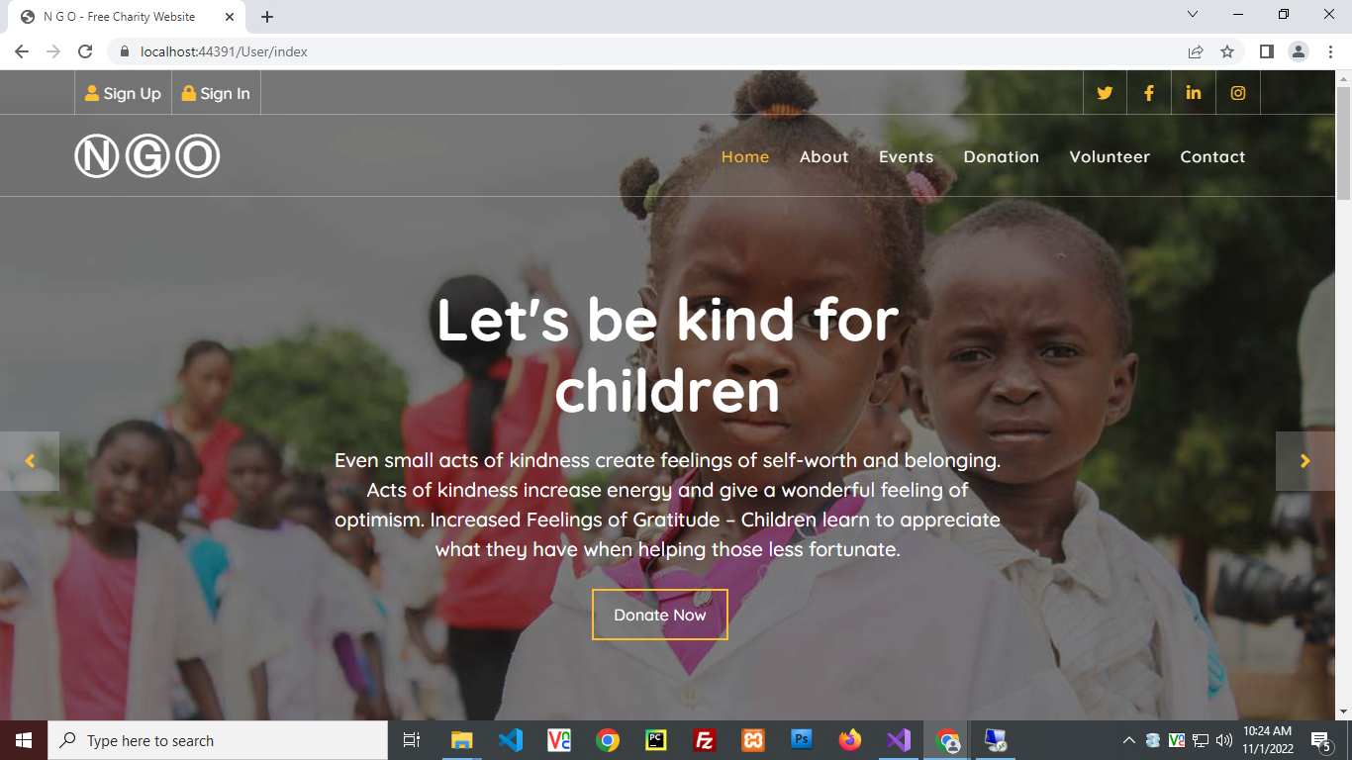

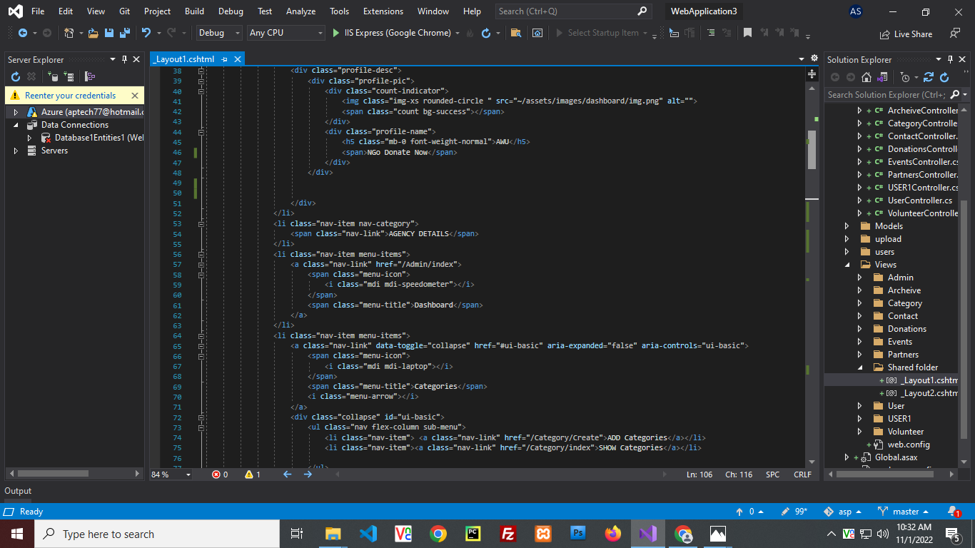



CHAPTER: 02

ABOUT US

This is the About Us Page.



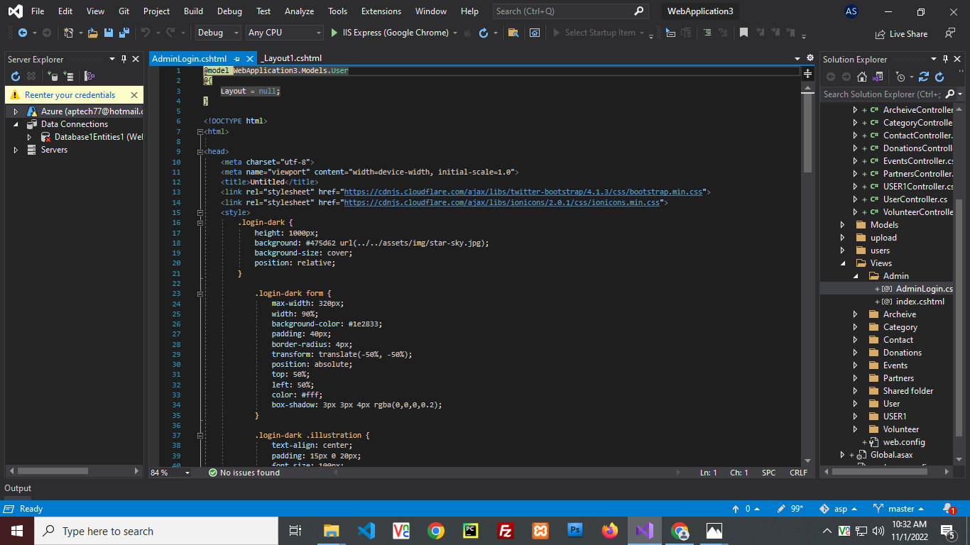



CHAPTER: 03

CONTACT US

This is the Contact us Page.

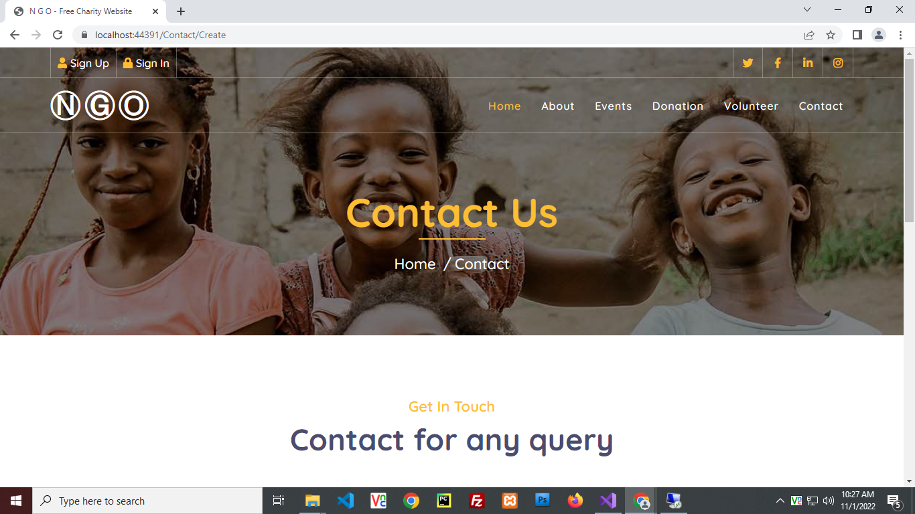

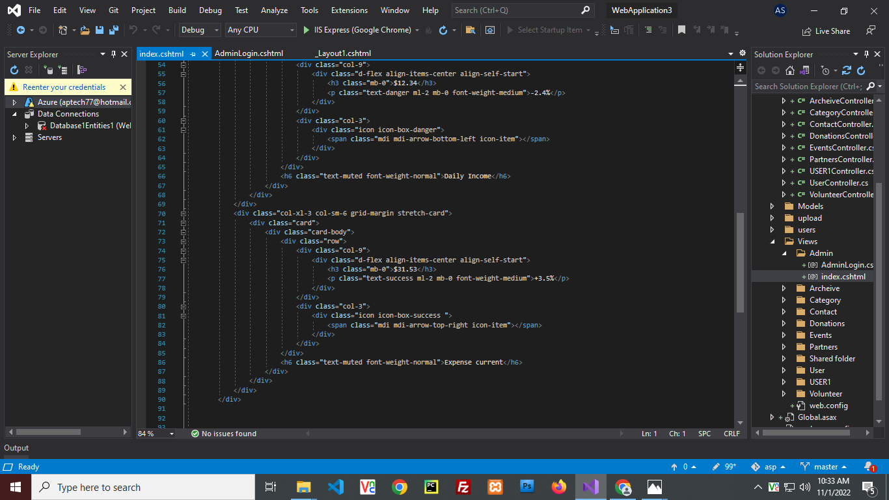



CHAPTER: 04

REGISTER YOURSELF

## 

This is where you Register yourself as a user.

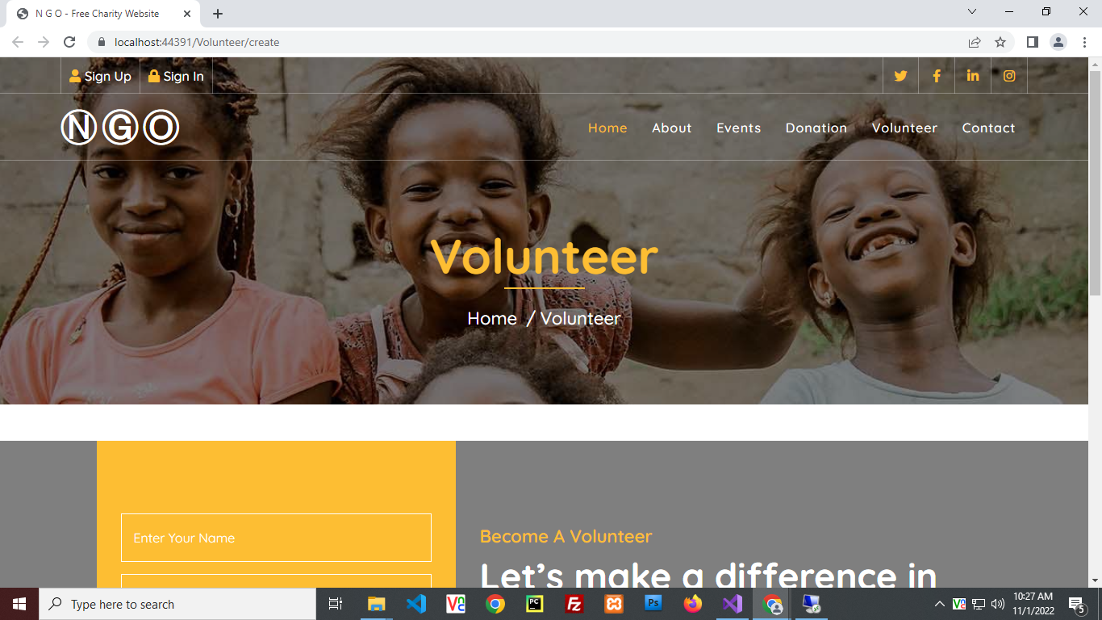

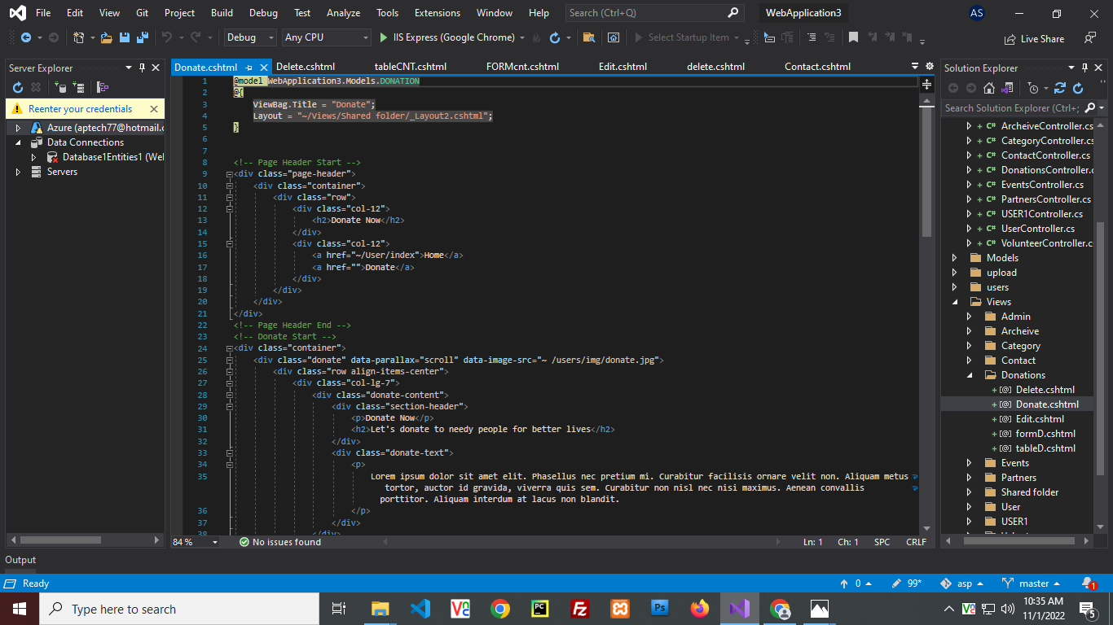



CHAPTER: 05

USER PANEL

After Signup you will go to Userlogin

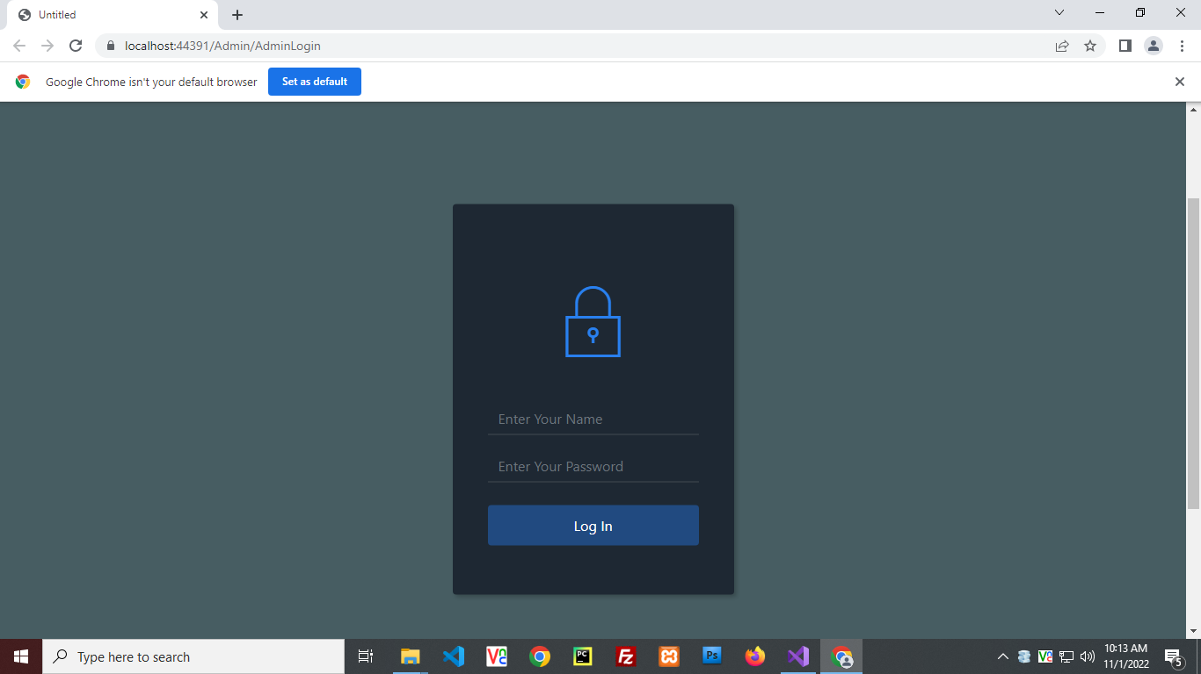

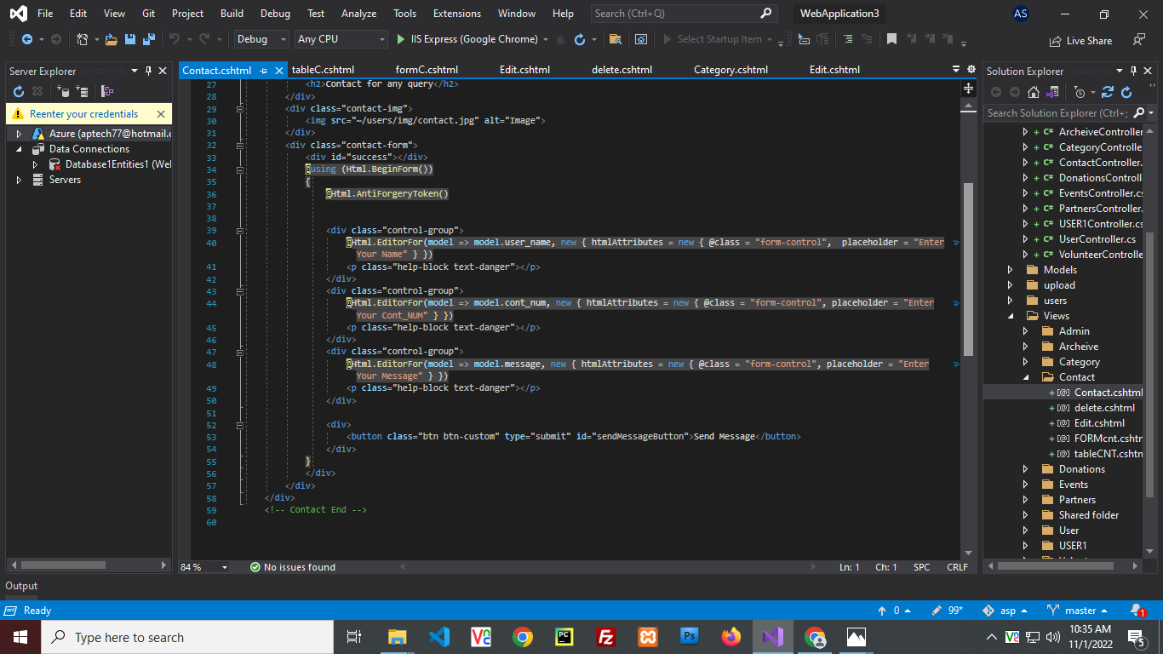

 CHAPTER: 06

ADMIN PANEL

This the Admin Login where the admin go into the Dashboard.

